

College Event Management System

Minor Project



TYBCA SEM-5

SDJ International College, Vesu



Bachelor of Computer Applications (BCA) Programme

Minor Project Report

BCA Sem V

AY 2024-25

*Project Title: ____________*

*by*

|  |  |  |
| --- | --- | --- |
| Exam No. | Roll No. | Name of Student |
|  |  |  |
|  |  |  |
|  |  |  |
|  |  |  |

**Project Guide by:**

**Acknowledgement**

The success and final outcome of this project required a lot of guidance and assistance from many people and we are extremely fortunate to have got this all along the completion of our minor project work. Whatever we have done is only due to such guidance and assistance.

I would not forget to thank I/C Principal Dr. Aditi Bhatt, IQAC coordinator and trust representative Dr. Vaibhav Desai, In-charge of IT Department Dr. Vimal Vaiwala , Head of the Department Prof.Nainesh Gathiyawala and Minor Project guide _________________and all other Assistant professors of SDJ International College, who took keen interest on our project work and guided us all along, till the completion of our project work by providing all the necessary information for developing a good system.

I am extremely grateful to her/him for providing such a nice support and guidance though she/he had busy schedule managing the college dealings.

I am thankful and fortunate enough to get support and guidance from all Teaching staffs of Bachelor of Computer Application Department which helped us in successfully completing our project work. Also, we would like to extend our sincere regards to all the non-teaching staff of Bachelor of Computer Application Department for their timely support.

**Student Name (Exam Seat Number)**

I N D E X

|  |  |  |
| --- | --- | --- |
| **Sr. No** | **Description** | **Page No.** |
| 1 | Introduction |  |
|  | 1.1 Project description |  |
|  | 1.2 Project Profile |  |
| 2 | Environment Description |  |
|  | 2.1 Hardware and Software Requirements |  |
|  | 2.2 Technologies Used |  |
| 3 | System Analysis and Planning |  |
|  | 3.1 Existing System and its Drawbacks |  |
|  | 3.2 Feasibility Study |  |
|  | 3.3 Requirement Gathering and Analysis |  |
| 4 | Proposed System |  |
|  | 4.1 Scope |  |
|  | 4.2 Project modules |  |
|  | 4.3 Module vise objectives/functionalities Constraints |  |
| 5 | Detail Planning |  |
|  | 5.1 UML – Use Case & Activity Flow Diagram |  |
|  | 5.2 Process Specification |  |
|  | 5.3 Entity-Relationship Diagram |  |
| 6 | System Design |  |
|  | 6.1 Database Design |  |
|  | 6.2 User interface |  |
| 7 | Software Testing |  |
| 8 | Limitations and Future Scope of Enhancements |  |
| 9 | References |  |

# 1. Introduction

## 1.1 Project Description

The College Event Management System is a comprehensive web-based application designed to streamline the process of organizing and managing events within a college environment. This system aims to automate various tasks such as event creation, registration, scheduling, and feedback collection, thereby reducing the administrative burden on event organizers and enhancing the overall experience for participants. By providing a centralized platform, the system ensures that all event-related activities are managed efficiently and effectively. Key features include user authentication, event listings, online registration, and feedback submission. Additionally, the system offers administrative functionalities to manage users, events, and registrations. The primary goal is to create an efficient, user-friendly, and scalable solution that can handle multiple events and users simultaneously. This system will not only save time and resources but also improve communication and coordination among all stakeholders involved in the event management process.

The system is designed to be intuitive and accessible, ensuring that users with varying levels of technical expertise can navigate and utilize its features effectively. By leveraging modern web technologies, the College Event Management System provides a responsive and interactive user interface that enhances user engagement. The system also incorporates robust security measures to protect user data and ensure the integrity of event information. With its modular architecture, the system can be easily extended and customized to meet the specific needs of different colleges. Overall, the College Event Management System represents a significant advancement in the way college events are managed, offering a reliable and efficient solution that benefits both organizers and participants.

## 1.2 Project Profile

1. **Project Name:** College Event Management System
2. **Technology Used:** PHP, MySQL, HTML, CSS, JavaScript
3. **Team Members:** [List of team members]
4. **Duration:** [Project duration]
5. **Objective:** To develop a robust system that simplifies event management processes and enhances user engagement.
6. **Scope:** The system will be used by students, faculty, and event organizers within the college.
7. **Outcome:** A fully functional web application that can be accessed via any web browser, providing a seamless experience for managing and participating in college events.

The project profile outlines the essential details of the College Event Management System, including the technologies used, team members involved, and the overall objective of the project. The system is built using a combination of PHP for server-side scripting, MySQL for database management, and HTML, CSS, and JavaScript for the front-end interface. This technology stack ensures that the system is both powerful and flexible, capable of handling the complex requirements of event management. The project involves a team of developers, designers, and testers who work collaboratively to deliver a high-quality solution within the specified duration. The primary objective is to create a system that not only simplifies the process of managing college events but also enhances user engagement through a user-friendly interface and interactive features. The scope of the project includes functionalities for event creation, registration, scheduling, and feedback collection, catering to the needs of students, faculty, and event organizers. The expected outcome is a fully functional web application that provides a seamless experience for managing and participating in college events, ultimately improving the efficiency and effectiveness of event management processes.

# 2. Environment Description

## 2.1 Hardware and Software Requirements

At Development Time…

* **Hardware Requirement**:
  + Intel® Core™ i5-9400f CPU @ 2.2-2.9GHz
  + Minimum 8.0 GB DDR4 RAM
  + 64-bit Operating System
  + 256 GB SSD, 1 TB HDD, 512 GB HDD, 256 GB HDD
* **Software Requirement:**
  + XAMPP
  + VS CODE
  + MySQL
  + Chrome
  + Brave
  + Working Internet Connection

CLIENT SIDE:

* **Hardware Requirements:**
  + Intel(R) Core (TM) i3-4005U CPU @ 1.70GHz 2.00GB RAM
* **Software Requirements:**
  + Windows 7 Ultimate or higher
  + Browsers: Mozilla Firefox, Google Chrome.

## 2.2 Technologies Used

The College Event Management System leverages a variety of technologies to ensure a robust, scalable, and user-friendly platform. Below are the key technologies used in the development of this system:

* **HTML (HyperText Markup Language):**
  + - HTML is the standard markup language used to create web pages. It provides the structure of the website, allowing the inclusion of text, images, and other multimedia elements. HTML forms the backbone of the web pages in the College Event Management System, ensuring that the content is well-organized and accessible.
* **CSS (Cascading Style Sheets):**
  + - CSS is used to control the presentation, formatting, and layout of the web pages. It allows for the separation of content from design, making it easier to maintain and update the look and feel of the website. CSS ensures that the College Event Management System has a consistent and visually appealing interface across all pages.
    - Cascading Style Sheets (CSS) are fundamental in shaping the visual presentation of a College Fest Management System (CFMS). By separating content from design, CSS enables developers to create an aesthetically pleasing and cohesive user interface that enhances the overall experience for students, faculty, and event organizers. In the context of a CFMS, effective use of CSS ensures that the application is not only functional but also visually engaging, encouraging higher user interaction and satisfaction.
    - One of the primary benefits of CSS is its ability to create responsive designs. Given the diverse range of devices that users may utilize—such as laptops, tablets, and smartphones—CSS allows developers to apply media queries that adjust the layout and styling based on the screen size. This adaptability ensures that users can easily navigate the CFMS, register for events, and access schedules without encountering formatting issues, regardless of the device they are using.
    - CSS also offers a variety of styling options to enhance the visual appeal of the CFMS. From color schemes and typography to spacing and alignment, CSS allows for detailed customization that aligns with the college’s branding. Consistent use of colors and fonts can create a professional and inviting atmosphere, making the system more approachable for users. Furthermore, CSS transitions and animations can be employed to add subtle interactive effects, making the experience more dynamic and engaging.
    - Additionally, using CSS preprocessors like SASS or LESS can streamline the styling process, allowing developers to write modular, maintainable code. This is particularly beneficial in larger projects like a CFMS, where consistent styling across multiple pages is essential.
    - In summary, CSS is an indispensable tool in developing a College Fest Management System, enhancing both aesthetics and usability. Its capabilities for responsive design, customization, and maintainability ensure that the CFMS not only meets functional requirements but also provides a delightful user experience.
* **JavaScript:**
  + - JavaScript is a programming language that enables interactive web pages. It is used to enhance the user experience by providing dynamic content updates, form validations, and other client-side functionalities. In the College Event Management System, JavaScript is used to create a responsive and interactive user interface.
    - JavaScript is a pivotal programming language in the development of a College Fest Management System (CFMS), adding interactivity and enhancing the user experience. As a client-side scripting language, JavaScript allows developers to create dynamic and responsive features that engage users and streamline various processes within the application. In the context of a CFMS, JavaScript can be utilized to manage event registrations, provide real-time updates, and improve overall functionality.
    - One of the primary advantages of JavaScript in a CFMS is its ability to handle user interactions seamlessly. For example, through the use of event listeners, developers can create responsive forms that validate user input in real-time, ensuring that participants receive immediate feedback on their registrations. This not only enhances the user experience but also reduces the likelihood of errors and incomplete submissions.
    - JavaScript also enables the implementation of asynchronous operations, such as AJAX (Asynchronous JavaScript and XML). This capability allows the CFMS to update content dynamically without requiring a full page refresh. For instance, students can view real-time updates on event schedules or receive notifications about upcoming deadlines, creating a more fluid and engaging interaction.
    - Moreover, JavaScript libraries like jQuery or frameworks such as React or Vue.js can further streamline development. These tools provide pre-built functions and components that simplify complex tasks, allowing developers to focus on creating unique features for the CFMS.
    - Additionally, integrating JavaScript with APIs can enhance the CFMS by allowing external data retrieval, such as pulling in social media feeds or integrating payment gateways for event ticketing.
    - In summary, JavaScript is an essential element in building a College Fest Management System, empowering developers to create interactive, real-time features that enhance user engagement and streamline event management. Its versatility and capabilities are crucial for delivering a modern, effective platform for college events.
* **PHP (Hypertext Preprocessor):**
  + - A College Fest Management System (CFMS) is an essential tool for organizing and executing events in a college environment, and PHP plays a crucial role in its development. PHP, a server-side scripting language, is well-suited for building dynamic web applications, making it an ideal choice for CFMS. With its ability to interact seamlessly with databases, PHP allows for efficient management of event data, including participant registrations, scheduling, and resource allocation. The CFMS can be designed to provide a user-friendly interface where students can easily register for events, view schedules, and receive updates.
    - Utilizing PHP’s frameworks, such as Laravel or CodeIgniter, enhances the development process by offering built-in functionalities that streamline coding and improve security. These frameworks provide features like routing, authentication, and templating, enabling developers to create a robust and scalable system. Furthermore, PHP's compatibility with various databases, such as MySQL, ensures that all event-related data can be stored and retrieved efficiently. This is particularly important for managing large volumes of information, such as participant lists and event feedback.
    - Moreover, PHP's strong community support means that developers can access a plethora of libraries and resources, further accelerating the development of the CFMS. Integrating features such as real-time notifications, ticketing systems, and feedback mechanisms enhances user engagement and satisfaction. In essence, using PHP in a College Fest Management System not only simplifies the complexities involved in event organization but also enriches the overall experience for both organizers and participants, paving the way for successful and memorable college events.
* **MySQL:**
* MySQL is a highly reliable and widely-used relational database management system that plays a critical role in the development and functioning of a College Fest Management System (CFMS). In the context of managing various college events, MySQL serves as the backbone for data storage, organization, and retrieval, enabling administrators and students to interact with the system seamlessly.
* At the core of a CFMS, MySQL handles essential functions such as participant registrations, event scheduling, resource allocation, and attendee feedback. The ability to manage large volumes of data efficiently is crucial, especially during peak registration times or when events are occurring simultaneously. MySQL’s structured query language (SQL) allows developers to execute complex queries, enabling real-time data analysis and reporting. For instance, organizers can easily generate attendance reports, analyze participation trends, or assess resource usage, which can inform decisions for future events.
* One of MySQL’s significant advantages is its capability to handle multiple concurrent connections. This feature ensures that students can register for events, view schedules, and receive updates without experiencing system slowdowns, even during high-traffic periods. Additionally, MySQL’s relational database model allows for the creation of interrelated tables, enabling complex data relationships. For example, tables can link participants to their respective events or connect sponsors to specific activities, facilitating better organization and management.
* Security is another key aspect of MySQL, as it provides robust features to protect sensitive information, such as personal details of participants. When integrated with PHP, MySQL enables developers to create dynamic, interactive web applications that respond in real-time to user actions. Overall, MySQL is an indispensable component of a College Fest Management System, offering the stability, efficiency, and scalability needed to ensure successful event management and an enhanced experience for both organizers and attendees.
* **Apache Web Server:**
  + - The Apache Web Server is an essential component of a College Fest Management System (CFMS), providing the infrastructure necessary for hosting and serving web applications. As one of the most widely used web servers globally, Apache is known for its reliability, flexibility, and robust performance, making it an ideal choice for managing dynamic web applications in a college environment.
    - In the context of a CFMS, Apache facilitates the delivery of web pages and resources to users, allowing students, faculty, and event organizers to access event information seamlessly. It supports various web technologies, including PHP, which is commonly used for developing server-side logic in CFMS. This integration allows the server to process requests, execute scripts, and interact with databases like MySQL efficiently, ensuring that users receive real-time updates on event schedules, registrations, and notifications.
    - One of the significant advantages of using Apache is its ability to handle multiple requests concurrently. This capability is crucial during peak registration periods or when events are taking place, ensuring that the system remains responsive and reliable. Additionally, Apache’s extensive module system allows for easy customization and enhancement of server capabilities. Features like URL rewriting, authentication, and caching can be implemented to improve user experience and enhance security.
    - Apache also provides robust logging and monitoring tools, enabling administrators to track usage patterns, identify potential issues, and optimize performance. This insight is invaluable for future planning and resource allocation, helping organizers improve the overall efficiency of college events.
    - In summary, the Apache Web Server is a vital infrastructure element in a College Fest Management System, delivering the stability, performance, and flexibility needed to support a dynamic and engaging college environment. Its integration with technologies like PHP and MySQL ensures a seamless experience for users while simplifying management for event organizers.
    - Apache is a widely-used open-source web server software. It is responsible for serving web pages to users and handling HTTP requests. The College Event Management System is hosted on an Apache server, ensuring that the website is accessible to users and can handle multiple concurrent connections.
* **Bootstrap:**
  + - Bootstrap is a popular front-end framework for developing responsive and mobile-first websites. It provides a collection of CSS and JavaScript components that help in creating a consistent and modern user interface. Bootstrap is used in the College Event Management System to ensure that the website is responsive and works well on different devices and screen sizes.
    - Bootstrap is a powerful front-end framework that plays a crucial role in developing a visually appealing and responsive College Fest Management System (CFMS). Designed to simplify web development, Bootstrap provides a robust collection of pre-designed components and styles, enabling developers to create an attractive and user-friendly interface quickly. In the context of a CFMS, the use of Bootstrap ensures that the application is not only functional but also engaging for students, faculty, and event organizers.
    - One of the standout features of Bootstrap is its responsive design capabilities. Given that users will access the CFMS on various devices—ranging from desktops to smartphones—Bootstrap’s grid system ensures that the layout adjusts seamlessly to different screen sizes. This responsiveness enhances user experience, allowing students to register for events, view schedules, and access information on the go, without sacrificing functionality or aesthetics.
    - Additionally, Bootstrap offers a wealth of ready-to-use UI components, such as buttons, forms, modals, and navigation bars. These elements can be easily customized to match the branding of the college, making the CFMS feel more cohesive and professional. By using these pre-built components, developers can save significant time during the development process, focusing on adding unique features and functionalities that enhance the system’s overall effectiveness.
    - Bootstrap also supports various JavaScript plugins that can be integrated to provide interactive features, such as dropdown menus, carousels, and alerts. These elements can add a layer of interactivity to the CFMS, keeping users engaged and informed about upcoming events, deadlines, and announcements.
    - In summary, Bootstrap is an invaluable asset in creating a College Fest Management System, offering the tools necessary to build a responsive, visually appealing, and user-friendly application. Its ease of use and flexibility make it an ideal choice for developers looking to enhance the college event experience for all stakeholders involved.

# 3. System Analysis and Planning

## 3.1 Existing System and its Drawbacks

The existing system for managing college events is primarily manual and paper-based, which presents several significant drawbacks. Event organizers have to handle registrations, schedules, and feedback manually, which is time-consuming and prone to errors. There is no centralized database to store event-related information, leading to data redundancy and inconsistency. Communication between organizers and participants is often inefficient, resulting in poor event management. Additionally, tracking attendance and collecting feedback is cumbersome, making it difficult to evaluate the success of events and plan future ones effectively. The lack of automation and integration in the current system results in significant administrative overhead and limits the ability to scale event management operations efficiently.

The manual nature of the existing system also poses challenges in terms of data security and accessibility. Sensitive information, such as participant details and feedback, is often stored in physical files, which are vulnerable to loss, damage, and unauthorized access. The absence of a centralized platform means that information is scattered across different locations, making it difficult to retrieve and manage. This fragmentation of data not only hampers the efficiency of event management but also affects the overall user experience. Participants may face delays in registration and communication, while organizers struggle to keep track of event details and participant information. The existing system's limitations highlight the need for a more efficient, automated, and integrated solution that can streamline event management processes, enhance data security, and improve communication and coordination among all stakeholders.

## 3.2 Feasibility Study

A feasibility study is essential to determine the viability of the proposed College Event Management System. The study evaluates the project from three key perspectives: technical, operational, and economic feasibility. From a technical standpoint, the proposed system will be developed using widely adopted technologies like PHP and MySQL, which are well-supported and have extensive documentation. The technical skills required for development are readily available, and the chosen technology stack ensures that the system will be robust, scalable, and maintainable. The use of modern web technologies also ensures that the system will be responsive and user-friendly, providing a seamless experience for users across different devices.

Operational feasibility focuses on the system's usability and its impact on existing processes. The proposed system will be user-friendly, with an intuitive interface that simplifies event management tasks. It will streamline processes, reduce administrative workload, and improve communication between organizers and participants. The system's modular design allows for easy customization and extension, ensuring that it can adapt to the specific needs of different colleges. Economic feasibility assesses the cost-effectiveness of the project. The cost of development is minimal as it utilizes open-source technologies. The primary investment will be in terms of time and effort from the development team. The long-term benefits of an efficient event management system outweigh the initial costs. The system will also reduce the need for physical resources, such as paper and printing, further lowering operational costs. Overall, the feasibility study indicates that the proposed College Event Management System is technically viable, operationally effective, and economically beneficial.

## 3.3 Requirement Gathering and Analysis

Requirement gathering and analysis are critical steps in the development of the College Event Management System. The process involves identifying the needs and expectations of various stakeholders, including students, faculty, and event organizers. User requirements focus on the functionalities that the system should provide to meet the needs of its users. The system should be accessible to students, faculty, and event organizers, providing functionalities like event creation, registration, scheduling, and feedback collection. Users should be able to log in, update their profiles, view event details, register for events, and submit feedback. Organizers should have the ability to create and manage events, track registrations, and analyze feedback. Administrators should be able to manage users, events, and registrations, ensuring that the system operates smoothly and efficiently.

Functional requirements specify the system's behavior and the tasks it should perform. Key functional requirements include user authentication, event management, registration management, feedback management, and administrative controls. The system should provide secure authentication and authorization mechanisms to protect user data and ensure that only authorized users can access specific functionalities. Non-functional requirements focus on the system's performance, security, and usability. The system should be secure, scalable, and maintainable, providing a responsive design for accessibility on various devices. It should ensure data integrity and provide robust error handling mechanisms to enhance user experience and reliability. By gathering and analyzing these requirements, the development team can ensure that the College Event Management System meets the needs of its users and delivers a high-quality solution that enhances event management processes.

# 4. Proposed System

## 4.1 Scope

The proposed College Event Management System aims to provide a comprehensive solution for managing events within a college. The system will include functionalities for event creation, online registration, scheduling, and feedback collection, catering to the needs of students, faculty, and event organizers. The system will support multiple user roles, including administrators, event organizers, and participants. Administrators will have the ability to manage users and events, ensuring that the system operates smoothly and efficiently. Event organizers can create and manage their events, track registrations, and analyze feedback to improve future events. Participants can register for events, view event details, and provide feedback, enhancing their overall experience and engagement.

The scope of the system extends beyond basic event management functionalities, offering advanced features to enhance user experience and streamline processes. The system will generate reports and analytics to help evaluate event success and plan future events. By offering a centralized platform, the system aims to enhance coordination and communication among all stakeholders, ensuring smooth and efficient event management. The system's modular design allows for easy customization and extension, enabling it to adapt to the specific needs of different colleges. The proposed system will not only save time and resources but also improve the overall efficiency and effectiveness of event management processes. By providing a user-friendly and scalable solution, the College Event Management System will significantly enhance the way college events are organized and managed.

## 4.2 Project Modules

* 1. **User Module**
     + User registration and authentication
     + Profile management
     + Event browsing and registration
     + Club membership management
  2. **Admin** **Module**
     + User management and role assignment
     + System-wide settings and configuration
     + Analytics and reporting dashboard
     + Approval processes for clubs and events
  3. **Club Module**
     + Club creation and management
     + Member management
     + Club-specific event creation
     + Club announcements and communications
  4. **Event Module**
     + Event creation and editing
     + Event categorization and tagging
     + Registration and attendance tracking
     + Event feedback and reporting

## Module-wise objectives/functionalities Constraints

1. **User** **Module**
   * Objectives:
     + Provide easy registration and login process
     + Allow users to manage their profiles and preferences
     + Enable users to browse and register for events
     + Facilitate club membership requests and management
   * **Constraints**:
     + Ensure data privacy and compliance with relevant regulations
     + Implement appropriate access controls based on user roles
2. **Admin Module** 
   * Objectives:
     + Centralize user management and role assignment
     + Provide system-wide configuration options
     + Offer comprehensive analytics and reporting tools
     + Streamline approval processes for clubs and events
   * Constraints:
     + Limit access to sensitive administrative functions
     + Ensure scalability to handle growing user base and data
3. **Club Module** 
   * Objectives:
     + Simplify club creation and management process
     + Facilitate member recruitment and management
     + Enable club-specific event creation and promotion
     + Improve communication between club leaders and members
   * Constraints:
     + Implement validation for club details to ensure data integrity
     + Manage club hierarchies and permissions effectively
4. **Event Module**
   * Objectives:
     + Streamline event creation and management process
     + Provide flexible event categorization and tagging
     + Automate registration and attendance tracking
     + Collect and analyze event feedback for improvements
   * Constraints:
     + Handle high traffic during popular event registrations
     + Ensure accurate attendance tracking and reporting

# 5. Detail Planning

## 5.1 Data Flow Diagram:

The use case diagram will illustrate the interactions between different actors (Admin, Club Organizer, Student) and the system. Key use cases include:

* 1. User Registration and Login
  2. Club Creation and Management
  3. Event Creation and Management
  4. Event Registration and Attendance
  5. Admin System Management

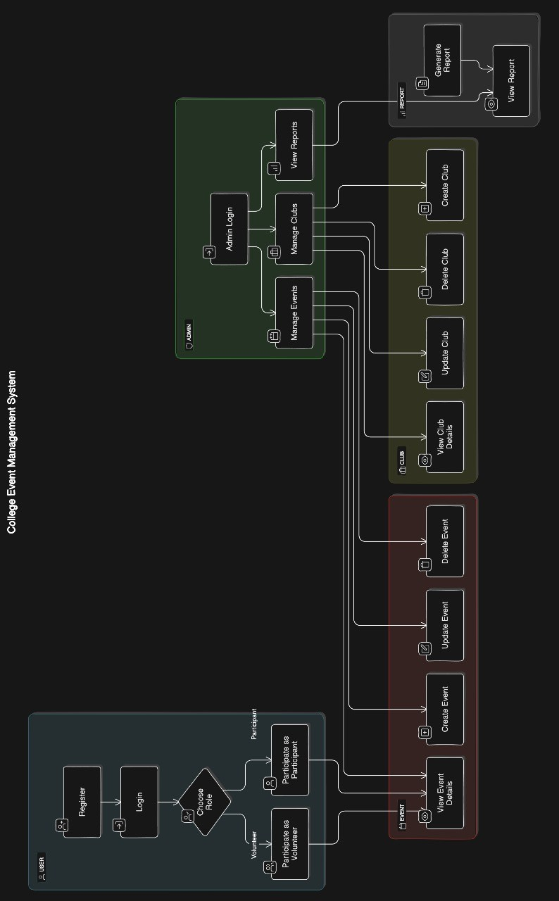

## 5.2 Process Specification

* Club Creation Process:
  + - User logs in and requests to create a club
    - Fills in club details (name, description, category)
    - Submits club for admin approval
    - Admin reviews and approves/rejects the club
    - If approved, user becomes club organizer
    - Club is listed in the system
* Event Creation Process:
  + - Club in and selects "Create New Event"
    - Fills in event details (name, date, venue, description)
    - Sets registration requirements and capacity
    - Submits event for admin approval (if required)
    - Admin reviews and approves the event
    - Event is published and visible to users
* User Registration and Event Participation:
  + - User browses available events
    - Selects desired event and registers
    - Receives confirmation and event details
    - Attends event and marks attendance (if applicable)
    - Provides feedback after the event

## 5.3 Entity-Relationship Diagram

The Entity-Relationship Diagram (ERD) will illustrate the database structure and relationships between different entities in the system. Key entities include:

* 1. Users (user_id, name, email, password, role)
  2. Clubs (club_id, name, description, creator_id, status)
  3. Events (event_id, name, description, date, club_id, status)
  4. Registrations (registration_id, event_id, user_id, status)
  5. ClubMembers (member_id, club_id, user_id, role)

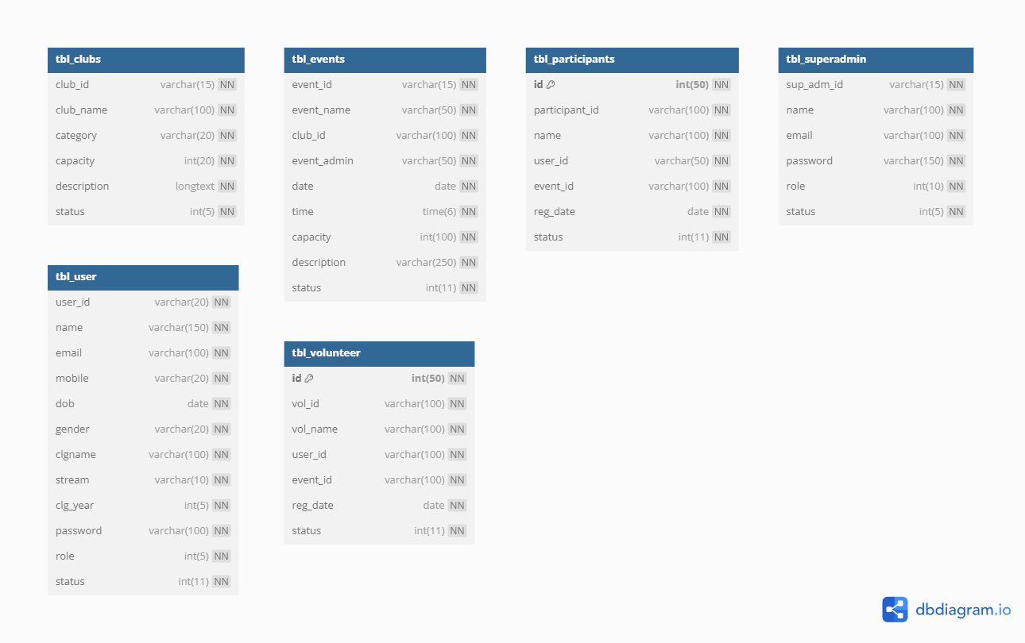

# 6. System Design

## 6.1 Database Design

The database design will be based on the Entity-Relationship Diagram, implemented using MySQL.

Key considerations include:

* 1. Normalization to minimize data redundancy
  2. Proper use of primary and foreign keys for maintaining data integrity
  3. Indexing for improved query performance
  4. Use of appropriate data types for efficient storage

|  |  |  |  |
| --- | --- | --- | --- |
| Table: tbl_clubs | | | |
| Field Name | **Data Type** | **Description** | **Constraints** |
| club_id | varchar(15) | Unique identifier for each club | NOT NULL |
| club_name | varchar(100) | Name of the club | NOT NULL |
| category | varchar(20) | Category to which the club belongs | NOT NULL |
| capacity | int(20) | Maximum capacity of the club | NOT NULL |
| description | longtext | Description of the club | NOT NULL |
| status | int(5) | Status of the club (e.g. active/inactive) | NOT NULL |

|  |  |  |  |
| --- | --- | --- | --- |
| Table: tbl_events | | | |
| Field Name | **Data Type** | **Description** | **Constraints** |
| event_id | varchar(15) | Unique identifier for each event | NOT NULL |
| event_name | varchar(50) | Name of the event | NOT NULL |
| club_id | varchar(100) | Identifier of the associated club | NOT NULL |
| event_admin | varchar(50) | Name of the event administrator | NOT NULL |
| date | date | Date of the event | NOT NULL |
| time | time(6) | Time of the event | NOT NULL |
| capacity | int(100) | Maximum capacity for the event | NOT NULL |
| description | varchar(250) | Description of the event | NOT NULL |
| status | int(5) | Status of the club (e.g. active/inactive) | NOT NULL |

|  |  |  |  |
| --- | --- | --- | --- |
| Table: tbl_participants | | | |
| Field Name | **Data Type** | **Description** | **Constraints** |
| id | int(50) | Unique identifier for each participant | NOT NULL |
| participant_id | varchar(100) | Unique identifier for the participant | NOT NULL |
| name | varchar(100) | Name of the participant | NOT NULL |
| user_id | varchar(50) | Identifier for the user | NOT NULL |
| event_id | varchar(100) | Identifier of the associated event | NOT NULL |
| reg_date | date | Registration date of the participant | NOT NULL |
| status | int(11) | Status of the participant registration | NOT NULL |

|  |  |  |  |
| --- | --- | --- | --- |
| Table: tbl_superadmin | | | |
| Field Name | **Data Type** | **Description** | **Constraints** |
| sup_adm_id | varchar(15) | Unique identifier for each superadmin | NOT NULL |
| name | varchar(100) | Name of the superadmin | NOT NULL |
| email | varchar(100) | Email address of the superadmin | NOT NULL |
| password | varchar(150) | Password for the superadmin | NOT NULL |
| role | int(10) | Role of the superadmin (e.g. admin, moderator) | NOT NULL |
| status | int(5) | Status of the superadmin (e.g. active/inactive) | NOT NULL |

|  |  |  |  |
| --- | --- | --- | --- |
| Table: tbl_user | | | |
| Field Name | **Data Type** | **Description** | **Constraints** |
| user_id | varchar(20) | Unique identifier for each user | NOT NULL |
| name | varchar(150) | Name of the user | NOT NULL |
| email | varchar(100) | Email address of the user | NOT NULL |
| mobile | varchar(20) | Mobile number of the user | NOT NULL |
| dob | date | Date of birth of the user | NOT NULL |
| gender | varchar(20) | Gender of the user | NOT NULL |
| clgname | varchar(100) | Name of the college | NOT NULL |
| stream | varchar(10) | Stream of study | NOT NULL |
| clg_year | int(5) | Year of study at the college | NOT NULL |
| password | varchar(100) | Password for user account | NOT NULL |
| role | int(5) | Role of the user (e.g. participant, volunteer) | NOT NULL |
| status | int(11) | Status of the user (e.g.active/inactive) | NOT NULL |

|  |  |  |  |
| --- | --- | --- | --- |
| Table: tbl_volunteer | | | |
| Field Name | **Data Type** | **Description** | **Constraints** |
| id | int(50) | Unique identifier for each volunteer | NOT NULL |
| vol_id | varchar(100) | Unique identifier for the volunteer | NOT NULL |
| vol_name | varchar(100) | Name of the volunteer | NOT NULL |
| user_id | varchar(100) | Identifier for the user | NOT NULL |
| event_id | varchar(100) | Identifier of the associated event | NOT NULL |
| reg_date | date | Registration date of the volunteer | NOT NULL |
| status | int(11) | Status of the volunteer registration | NOT NULL |

## 6.2 User interface

The user interface will be designed with a focus on usability, responsiveness, and aesthetic appeal.

* **Admin Side Login**

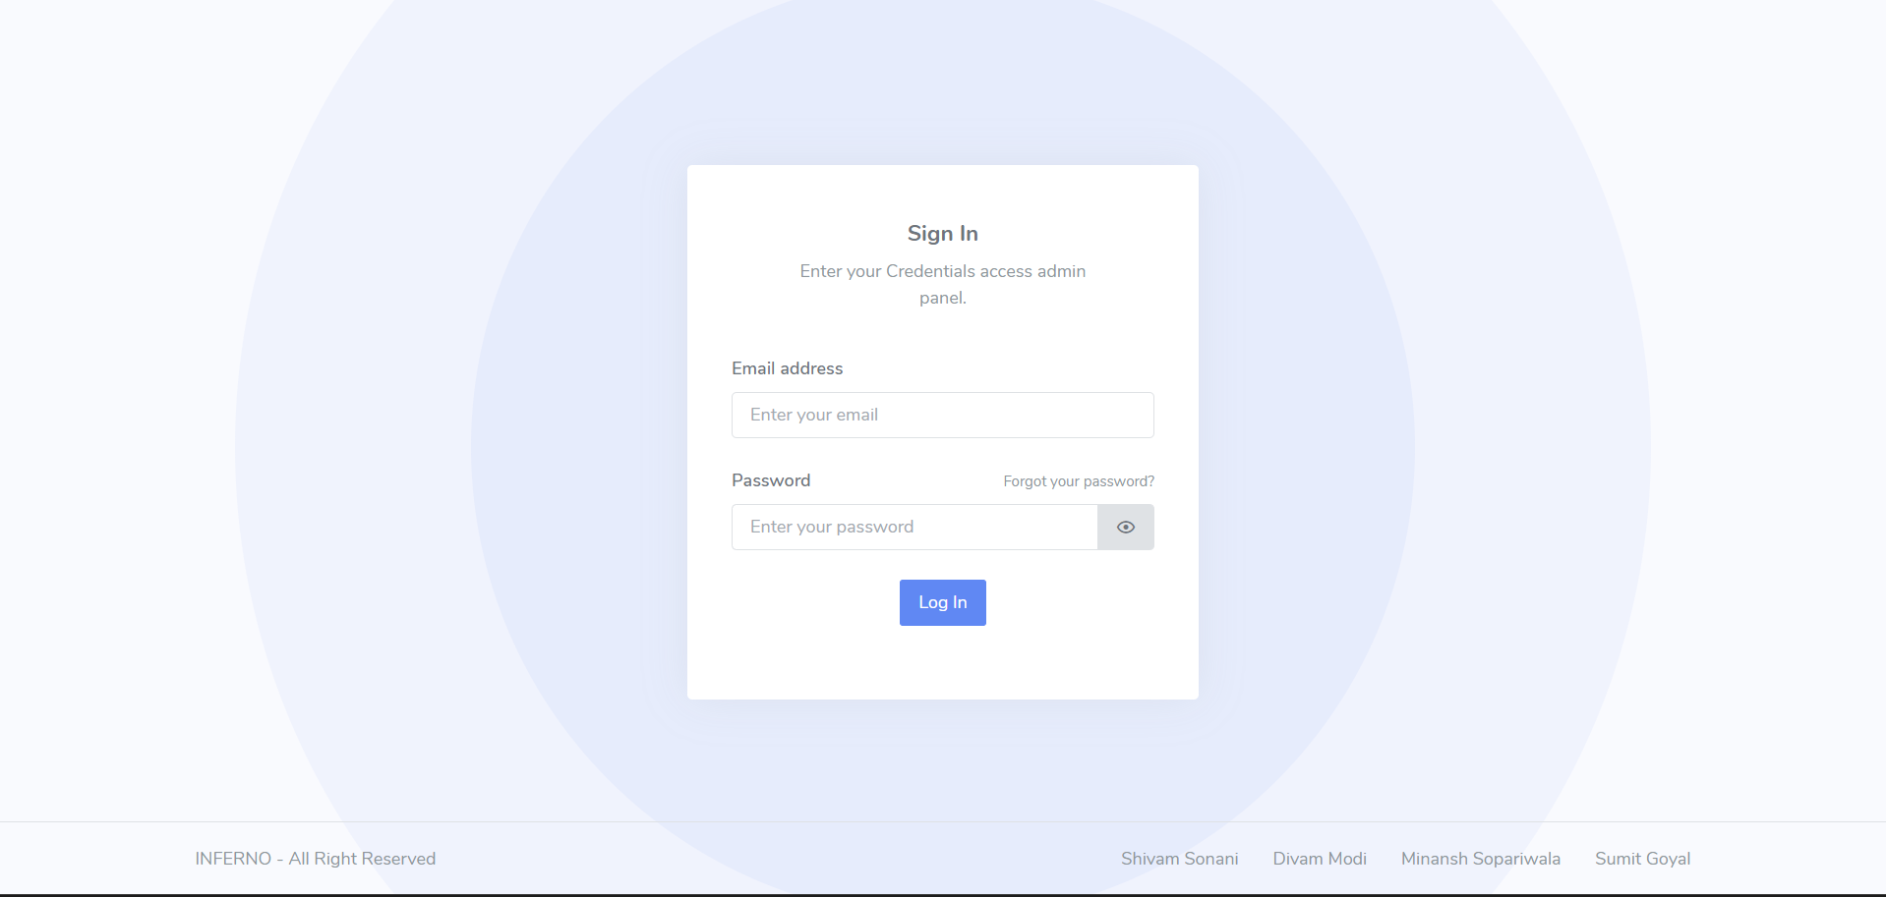

* **Admin Dashboard:**

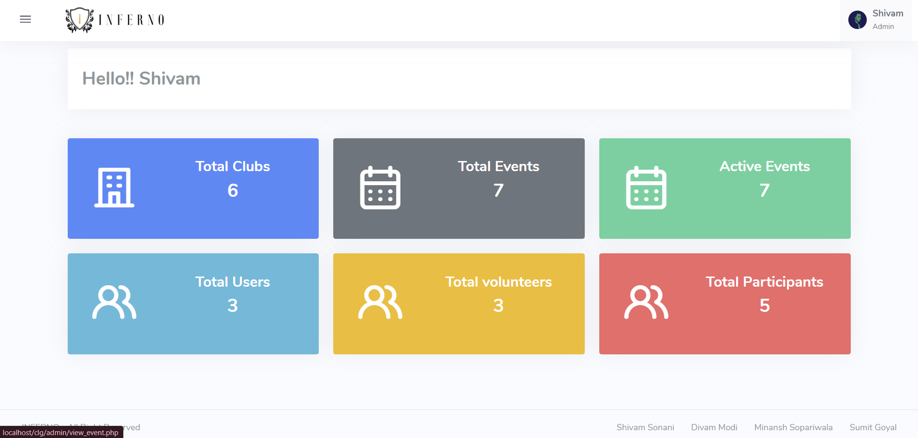

* **Club List**

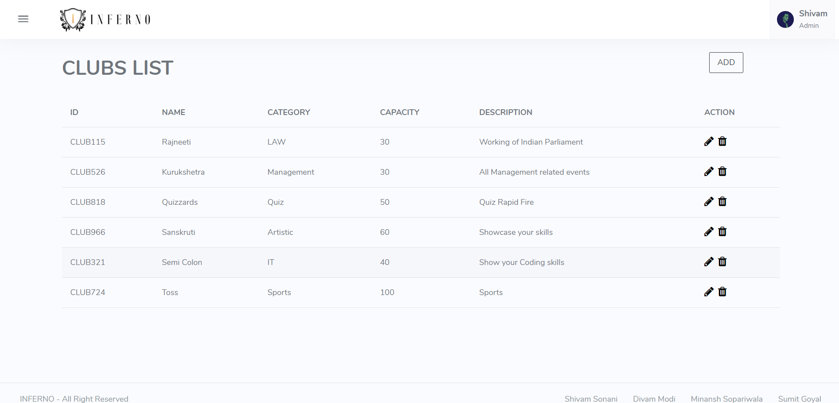

* **Event List ( Admin Side):**

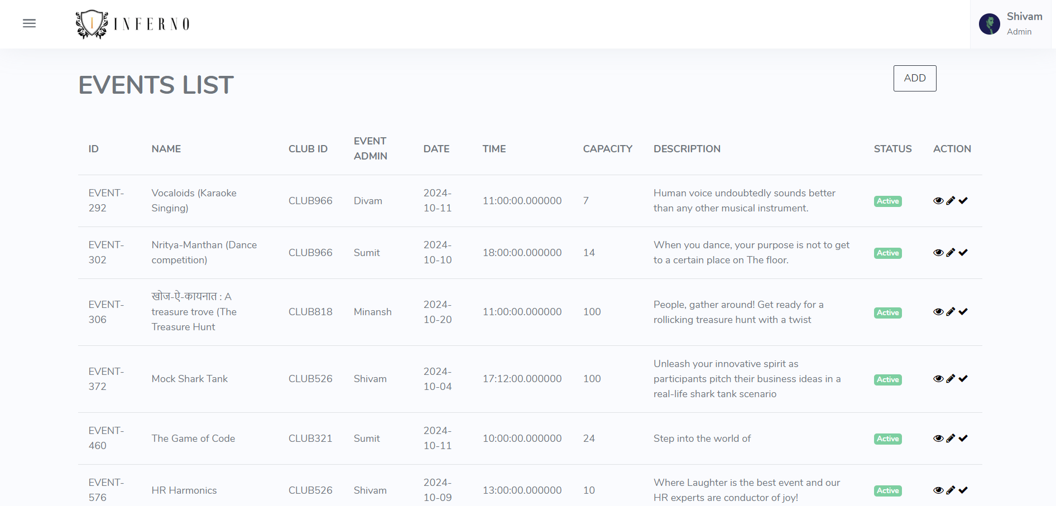

* **Participant List:**

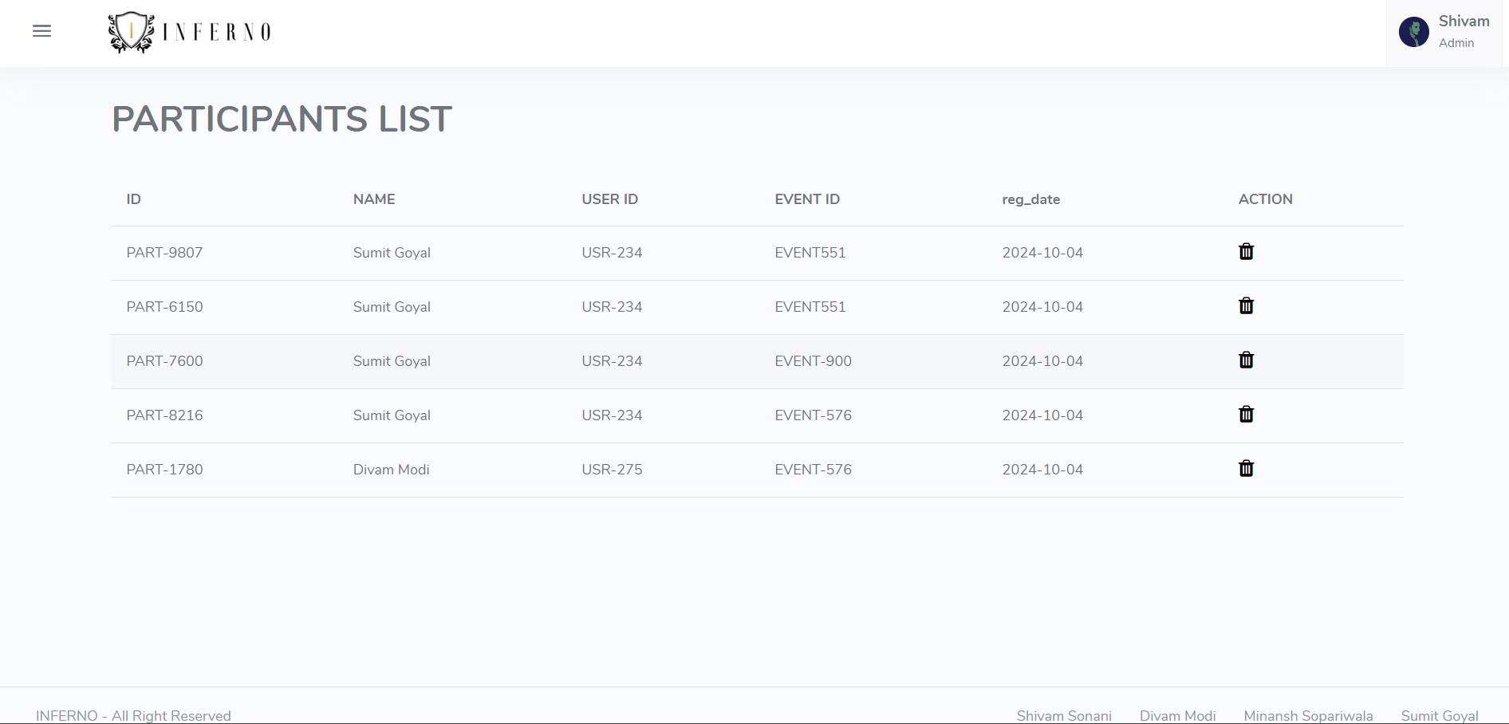

* **Volunteer List:**

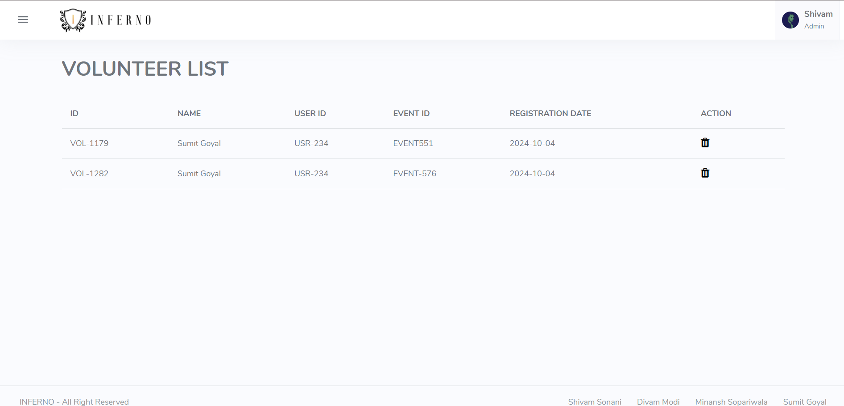

* **Create Club**

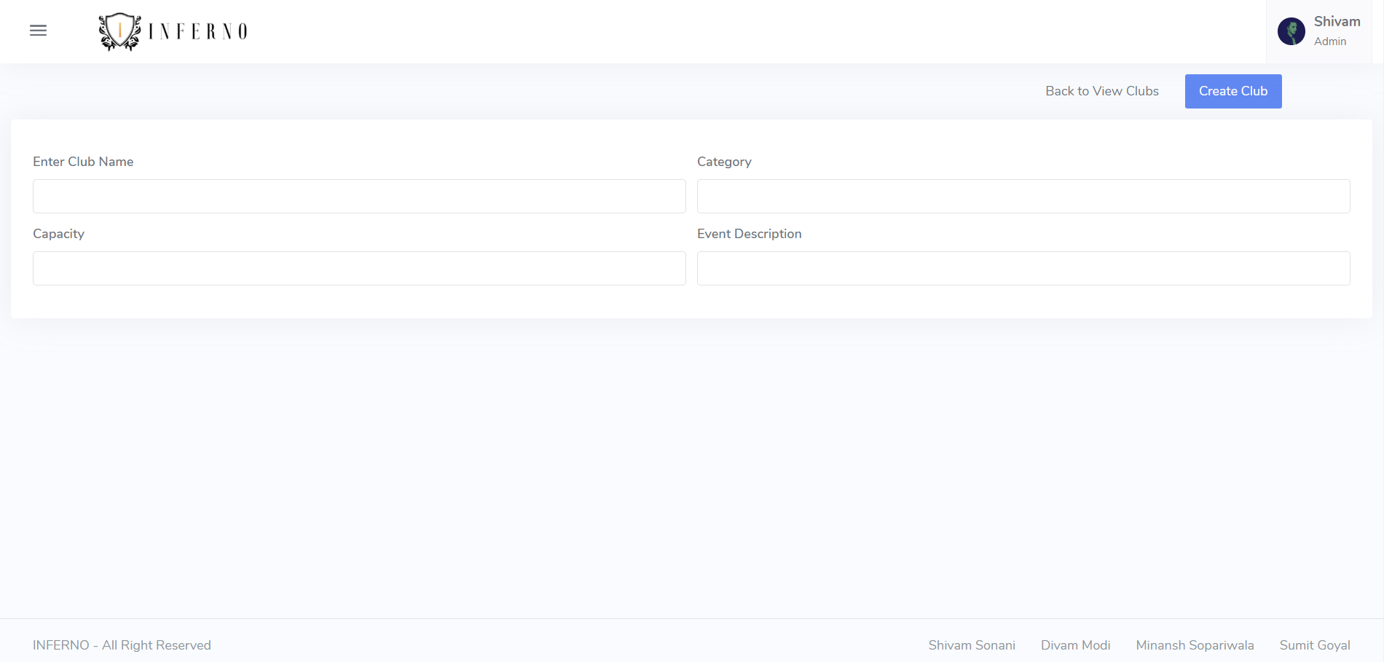

* **Create Event:**

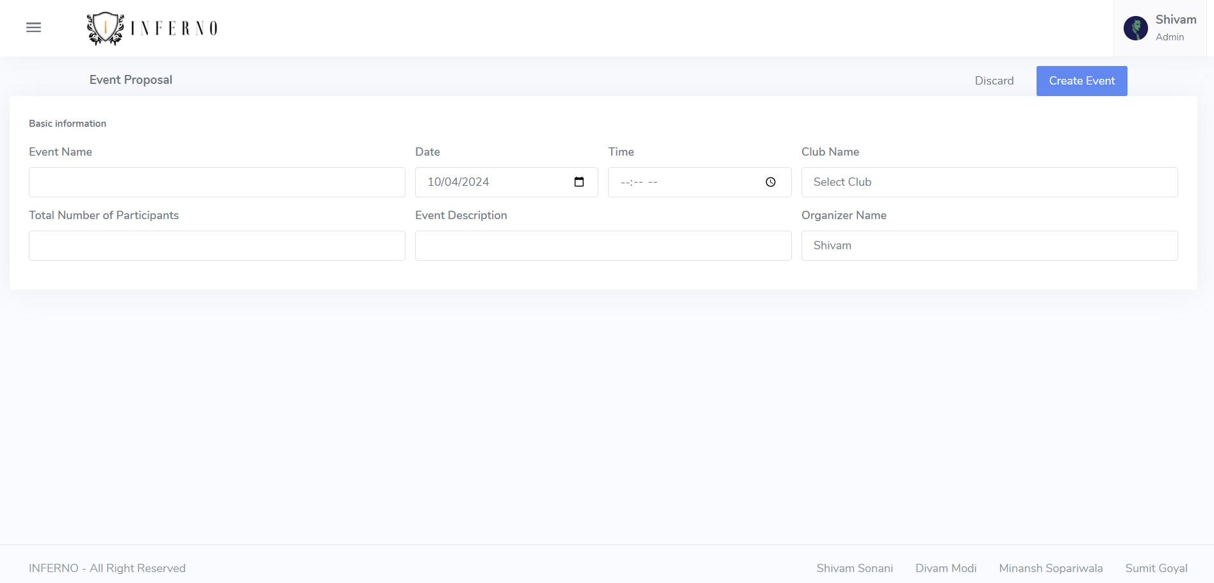

* **Update Club:**

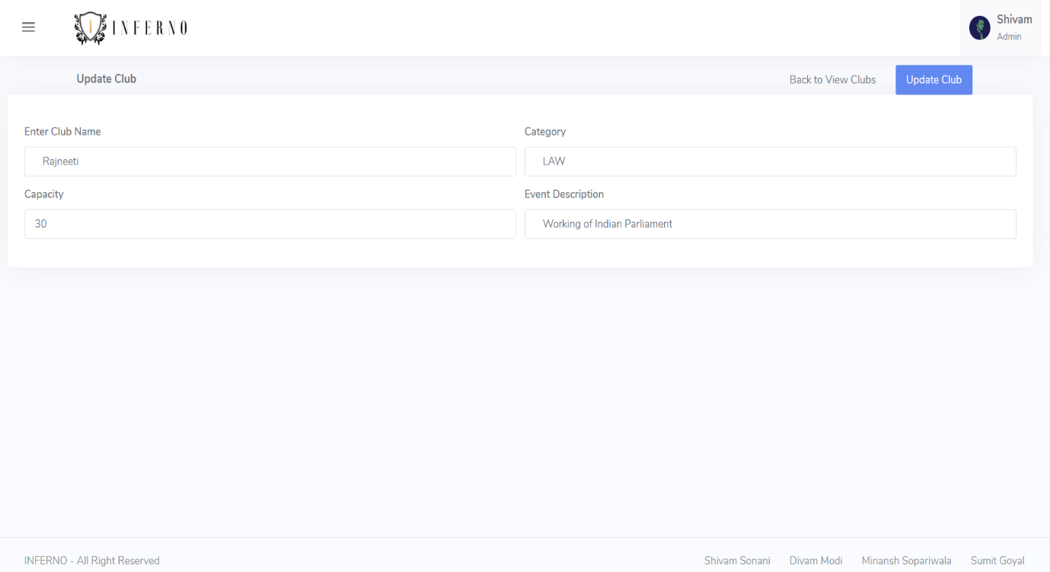

* **Update Event**

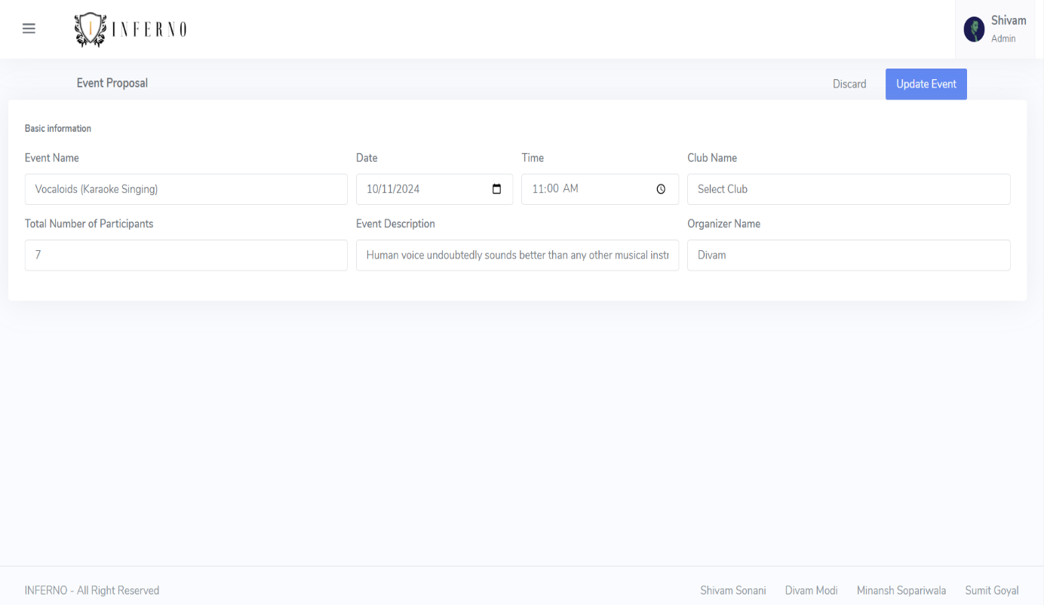

* **Delete Club:**

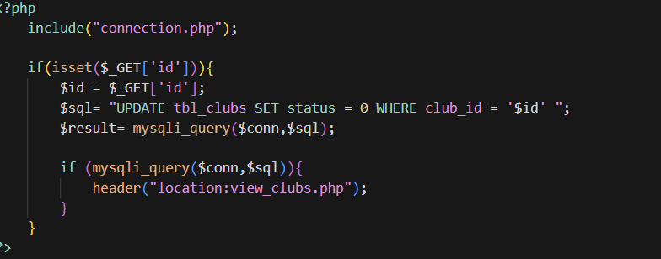

* **Delete Event:**

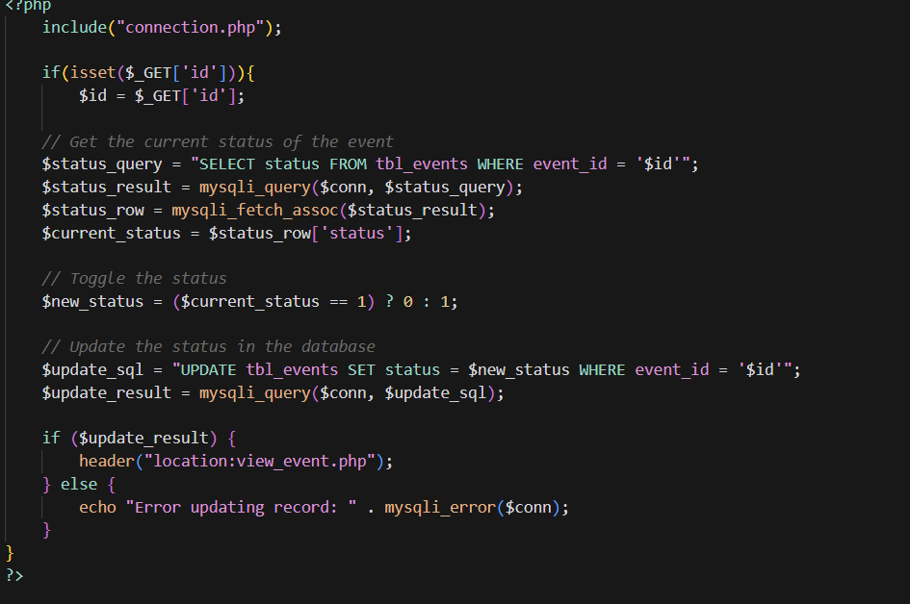

* **Delete Participants:**

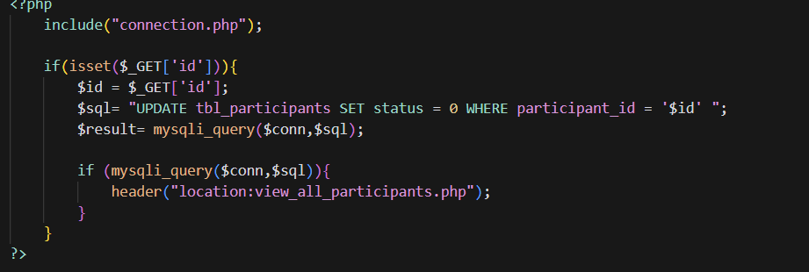

* **Delete Volunteer:**

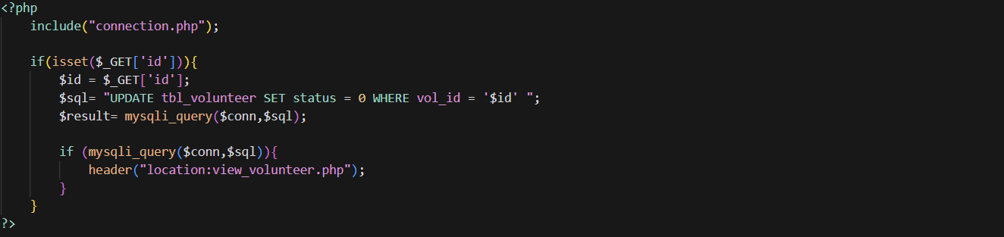

# 7. Software Testing

The testing phase will ensure the quality, reliability, and performance of the College Event Management System.

Testing strategies include:

## Unit Testing:

* + - Develop and run unit tests for individual components and functions
    - Use PHPUnit framework for automated testing of PHP code
    - Aim for high code coverage to catch potential bugs early

## Integration Testing:

* + - Test the interaction between different modules (e.g., club creation and event management)
    - Ensure data flows correctly between components and database

## User Acceptance Testing (UAT):

* + - Involve stakeholders (admin, club organizers, students) in testing
    - Gather feedback on usability and functionality
    - Make necessary adjustments based on UAT results

## Performance Testing:

* + - Simulate high user loads to test system performance and scalability
    - Identify and optimize bottlenecks in database queries or server-side processing

## Security Testing:

* + - Conduct vulnerability assessments and penetration testing
    - Ensure proper input validation and protection against common web vulnerabilities (e.g., SQL injection, XSS)

## Cross-browser and Cross-device Testing:

* + - Verify compatibility across different browsers and devices
    - Ensure responsive design works as intended on various screen sizes

# Limitations and Future Scope of Enhancements

## Current Limitations:

* Limited User Engagement Features: Many CFMS platforms lack robust features for engaging users beyond event registration, such as community forums, chat functions, or social media integration, which can diminish user interaction and feedback.
* Inadequate Mobile Responsiveness: While some systems claim to be mobile-friendly, they may not provide an optimal experience on all devices, leading to frustration among users who attempt to access the system on smartphones or tablets.
* Data Management Challenges: Many CFMS platforms struggle with effectively managing large volumes of data, such as participant information, feedback, and event logistics. This can lead to slow performance and difficulties in data retrieval and reporting.
* Insufficient Customization Options: Some systems offer limited customization, restricting colleges from tailoring the platform to fit their unique branding and event needs, which can hinder the overall user experience.
* Lack of Real-Time Updates: Not all CFMS platforms provide real-time updates for event schedules or changes. This can lead to confusion among participants and missed opportunities for engagement.
* Security Concerns: With sensitive information such as personal data and payment details being processed, some CFMS platforms may not implement robust security measures, making them vulnerable to data breaches and unauthorized access.
* Integration Limitations: Many CFMS platforms face challenges in integrating with other software or tools, such as learning management systems or social media platforms, limiting their functionality and ease of use.
* User Training and Support: Often, there is inadequate training and support for users and administrators, which can hinder effective usage of the system and lead to underutilization of available features.
* Cost Implications: Some comprehensive CFMS solutions can be costly, making them less accessible for smaller colleges or those with limited budgets.

## Future Enhancements:

* 1. Advanced Analytics and Reporting:
     1. Implement data visualization tools for better insights
     2. Develop predictive analytics for event success and attendance
  2. Mobile Application:
     1. Develop native mobile apps for iOS and Android for improved user experience
     2. Implement push notifications for event reminders and updates
  3. Integration with External Systems:
     1. Allow synchronization with popular calendar applications
     2. Integrate with the college's learning management system
  4. Enhanced Customization:
     1. Provide more options for customizing club and event pages
     2. Implement a theme system for different types of events
  5. Resource Management:
     1. Add features for managing event resources (e.g., rooms, equipment)
     2. Implement a booking system for college facilities
  6. Feedback and Rating System:
     1. Develop a comprehensive feedback system for events and clubs
     2. Implement a rating system to highlight popular events and clubs
  7. Social Features:
     1. Add social networking features to connect students with similar interests
     2. Implement a discussion forum for each club and event
  8. Internationalization and Localization:
     1. Add support for multiple languages to cater to international students

# References

* 1. PHP Documentation: <https://www.php.net/docs.php>
  2. MySQL Documentation: <https://dev.mysql.com/doc/>
  3. CodeIgniter 4 Documentation: <https://codeigniter.com/user_guide/index.html>
  4. Bootstrap Documentation: <https://getbootstrap.com/docs/>
  5. PHPUnit Documentation: <https://phpunit.de/documentation.html>
  6. Web Content Accessibility Guidelines (WCAG): <https://www.w3.org/WAI/standards-guidelines/wcag/>
  7. OWASP Web Security Testing Guide: <https://owasp.org/www-project-web-security-testing-guide/>
  8. Event Management Best Practices: [relevant books or articles on event management]
  9. UML Diagram References: [UML specification or modeling tool documentation]